Fruits
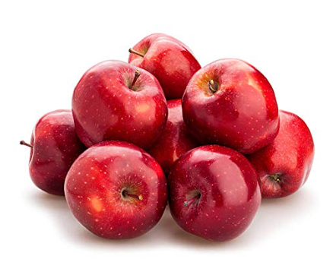
1.
$1.02 each
Fresh Red Lady Apple,
Avg. 0.5 lb
Description :
This Red Lady apple, semi- sweet, crispy and Juicy, with very little tartness, enjoy this apple with your favorite cheese and crackers.

2. Mango
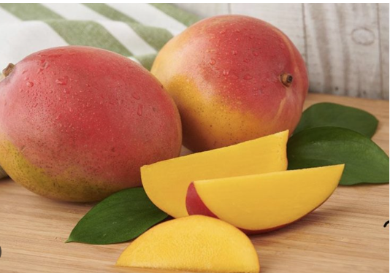
$0.50 each
Fresh Mango, ea
Avg 0.9 lb
Description:
Mangoes vary in size, shape, and color, but they are typically oval or round with a smooth skin that ranges from green to various shades of yellow, orange, or red when ripe. The skin may have small blemishes or spots. The taste is a harmonious balance of sweetness and tartness, creating a unique and refreshing flavor profile
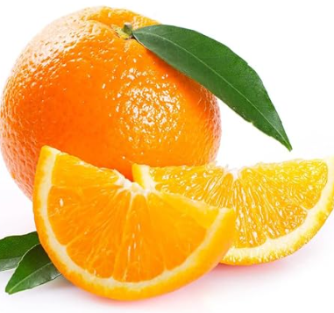
3.Oranges

$1.05 each
Fresh Large Navel Orange,
Avg. 0.62 lb

Description:
This large fresh navel oranges have big flavor! Sweet, juicy, and tart, enjoy this circuit fruit as a quick snack, or add to savory and sweet recipe for a punch of bright flavor.

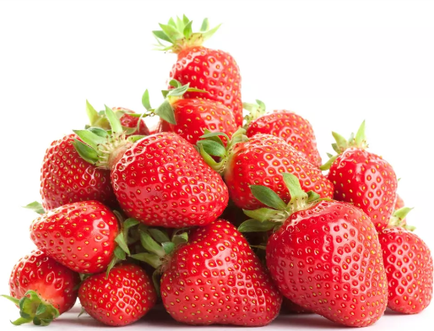
4. Strawberries

$2.99 each
Fresh Strawberries, 1lb

Description:
Beautiful and sweet, strawberries are a favorite among all ages. Strawberries are one of the most versatile and popular fruits around, they are associated with the prevention of cardiovascular diseases and certain types of cancer. They are among the fruits and vegetables ranked highest in health-promoting antioxidants and anti-inflammatory nutrients.

5. Bananas
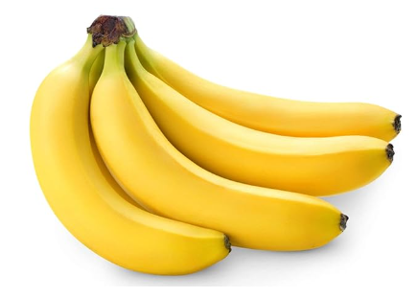

$1.50 each
Fresh Bunch of Bananas,
Avg. 2.48 lbs

Description:
Pick up a perfect option for a quick breakfast or on-the-go snacking with this Banana. A good source of potassium, the banana is great for adding to oatmeal, cereal, ice cream and more. Plus, you can also blend it with yogurt and other favorite fruits to whip up a delicious smoothie.
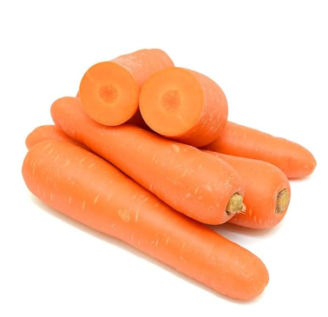
Vegetables
1. Carrots

$0.28 each
Fresh Carrots,
Avg 0.4lb

Description:
Carrots are crisp, vibrant root vegetables prized for their natural sweetness and versatility. Packed with essential nutrients like beta-carotene, they offer a healthy boost to your diet. Enjoy them raw in salads, cooked in hearty dishes, or as a crunchy snack for a nutritious and flavorful culinary experience.

2. Beetroot
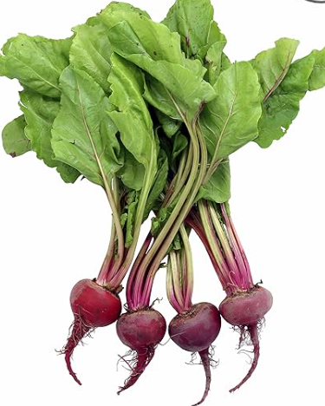
$2.58 each
Fresh Beets, Bunch

Description:
Beets, with their rich, earthy flavor and vibrant color, are a versatile and nutritious addition to any meal. Packed with essential vitamins, minerals, and antioxidants, they offer a range of health benefits. Whether roasted, boiled, or grated fresh into salads, beets bring a unique and delicious touch to your culinary creations.

3. Cabbages

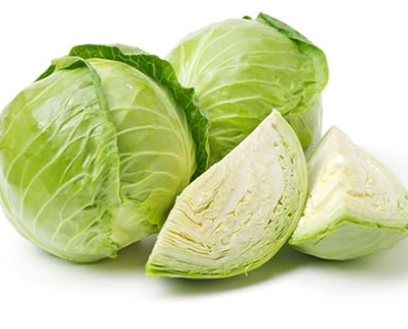

$1.50 each
Fresh Green Cabbage,
Avg. 2.50

Description:
Fresh cabbage offers a satisfying crunch that livens up salads and stir fry. A versatile vegetables that can be enjoyed fresh or cooked, try simmering on the stove top or sauteing with other vegetables for a cruciferous addition to your next culinary creation.

4. Cauliflower

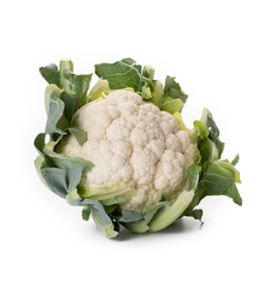
Fresh Cauliflower
$2.50 Each
Description:
Cauliflower is high in nutrients and can be used as a carbohydrate alternative.

5. Tomatoes
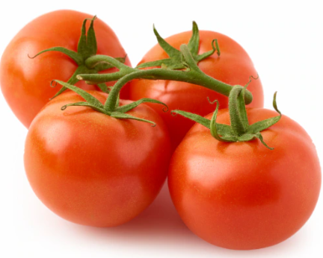

Fresh Vine Ripe Tomatoes
$ 1.50 each, avg 0.85 lb

Breakfast Specials

1.Oats
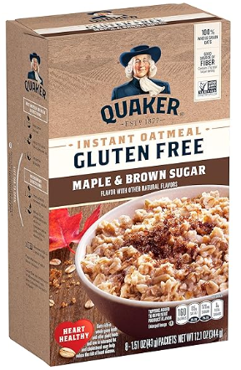

Quaker Maples & Brown Sugar
Instant Oatmeal, 8 ct
$2.88 each
Description:
Help start your morning with the wholesome goodness of Quaker Oats packed with the rich tastes of maple and brown sugar in an Instant Oatmeal package. Prepare for all that lies ahead by filling your bowls, bellies and hearts with the love of nourishing breakfast. Just because you've got a busy day doesn't mean you don't deserve all the goodness Quaker has to offer.

2.Corn Flakes Breakfast Cereal

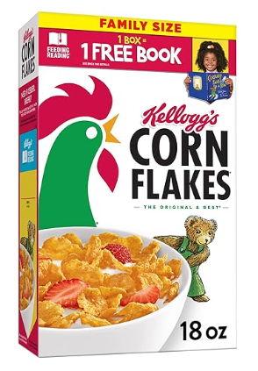

Kellogg's Corn Flakes Breakfast Cereal,
Family Size, Original, 18oz
$4.98 each

Description:
Greet your morning with Kellogg’s Corn Flakes cereal, a healthy, delicious breakfast cereal that helps you start the day right. Includes one, 18-ounce box of this classic family favorite cereal, perfect for kids and adults. Made to enjoy by the bowlful, each serving contains a good source of eight vitamins and minerals, is fat free, and contains no artificial colors or flavors; You can also use these flakes to prepare numerous sweet and savory dishes. Kellogg's Corn Flakes can be used whole and incorporated into casseroles, crushed for your favorite Corn Flakes Crusted Chicken recipe, or added to a yogurt parfait for some extra crunch. Just add your favorite dairy or nut milk to Kellogg’s Corn Flakes, the Original and Best.

3.Pancake Mix
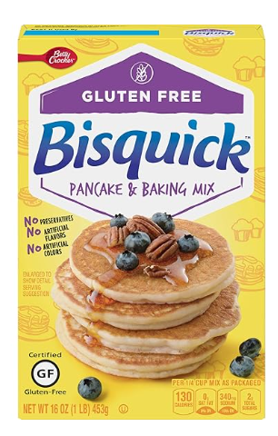
Bisquick Baking Mix &
Gluten Free Pancake, 16oz
$ 5.24 each
Description:
Gluten free Pancake mix makes fluffy, mouth watering pancakes, waffles, and more. Quick easy breakfast, just add water and pour onto griddle.

4. Diary Products

1.Milk
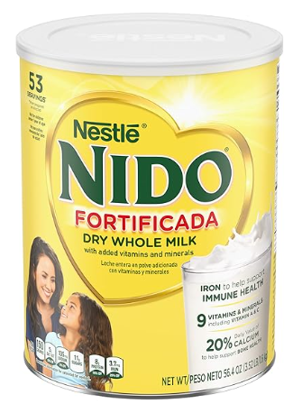
NIDO Fortificada Dry Whole Milk ,
3.52 Pound(Pack of 1)
$ 19.58
Description:
NIDO Fortificada Dry Whole Milk Powdered Drink Mix delivers 5 essential vitamins and minerals in every cup. This dry whole milk beverage for ages 4 and up contains calcium, zinc, Vitamin A, Vitamin C and iron. This dry whole milk beverage is easy to mix. Simply add 4 tbsp of Nestle NIDO Fortificada to 1 cup of warm water and mix well for a nutritious beverage the whole family can enjoy. Each 56.4 ounce canister of dry whole milk beverage contains approximately 53 servings of NIDO Whole Milk drink. Store your can of Nestle NIDO Fortificada in a cool, dry place.

2.Cheese
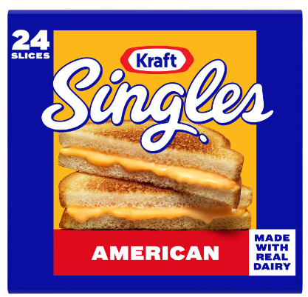
Kraft Singles American Sliced Cheese
24 ct
$5.15 each
Description:
Delicious any way you square it, Kraft Singles slices deliver the classic American taste and irresistible melt that take your favorite foods to the next level. Made with real dairy and no artificial flavors or preservatives, this sliced cheese has a mild, savory flavor and smooth, creamy texture that’s perfectly melty. The individually-wrapped simple squares are ideal for more than just grilled cheese. Try adding to your breakfast sandwich, burger or tuna melt or transform steak and bread into a Philly cheese steak. Or when you're craving classic comfort food, add America's favorite square to your mac and cheese.
3.Yogurt
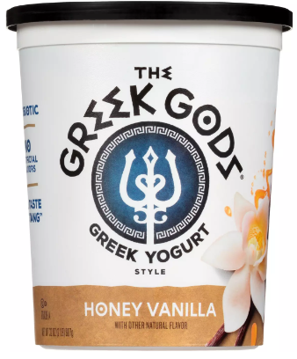
The Greek Gods Honey Vanilla Greek Yogurt
32oz
$ 5.60 each
Description:
The Greek Gods® Honey Vanilla Greek-Style Yogurt is a combination of our fan favorite honey yogurt with a hint of vanilla to create a sweet, creamy delicacy with a rich taste.

4.Butter

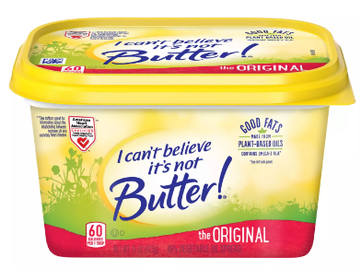
I Can't Believe It's Not Butter!
Original Spread Butter 15oz
$ 4.19 each
Description:
I Can#t Believe It#s Not Butter! Original spread is made with good fats from plant-based oils like omega-3 ALA. It meets the nutritional requirements of the American Heart Association Heart-Check certification program. Made with simple ingredients, with a delicious blend of oils, purified water, and a pinch of salt. I Can#t Believe It#s Not Butter! Original has an unbelievable buttery flavor in a deliciously simple recipe. This irresistibly creamy spread contains no artificial flavors, no artificial preservatives, and 0 grams trans fat per 1 tablespoon serving. It has 60 calories per 1 tablespoon serving and 70% less saturated fat than butter.
5. Ice Cream
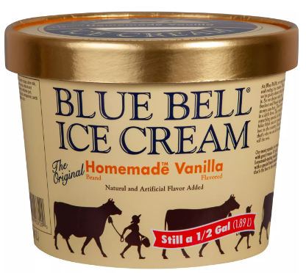
Blue Bell Homemade
Vanilla Ice Cream ½ gal
$ 8.50 each
Description:
Blue Bell Homemade Vanilla is our most popular ice cream and with good reason. It's rich, homemade-tasting vanilla ice cream with a special hand-cranked flavor that's the best in the country.
6.Sour Cream
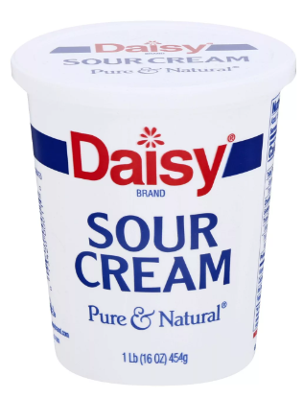
Daisy Sour Cream
16 oz
$2.45 each
Description:
Daisy Sour Cream is made with nothing but real dairy ingredients and no preservatives. Which means when you use Daisy in your favorite dishes, you get a clean, fresh taste and rich, creamy texture that makes eyes light up with every delicious dollop.
- Cheese Stick
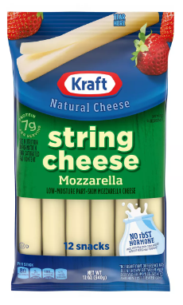
Kraft Mozzarella String Cheese
12 ct
$4.25 each
Description:
These Kraft String Cheese Blocks are Perfect for Snacking, added to Charcuterie Boards, Crackers, Antipasto, and Dips. Stack with Prosciutto, Use in Caprese Salads, Dip in Cocktail Sauce (You'll be hooked!) Perfect Snacks for Adults and Kids, Fry for Homemade Mozzarella Sticks. Add to your Wine & Cheese Gifts, Beer & Cheese Gift Basket, Send to your Cheese Loving Friends & Family Members.

5. Juice
1. Orange Juice
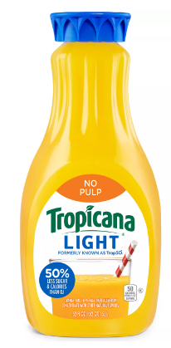
Tropicana Light No Pulp Orange Juice
52 oz
$4.20 each

Description:
Boasting half the calories and sugar, Tropicana Trop50 orange juice is a delicious way to get your daily dose of vitamin C and potassium. Made with real oranges and no artificial sweeteners, each serving is pulp-free and 50 calories.
2. Apple Juice

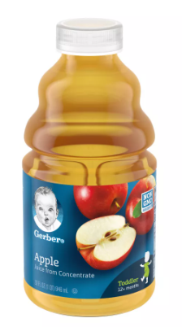
Gerber Toddler Fruit Juice – Apple
32 oz
$2.58 each
Description:
Gerber 100% Apple Juice offers a delicious, naturally sweet toddler drink option to keep in your refrigerator. The goodness in every bottle starts with juice from 6 1/2 apples picked from the trees and never from the ground. Each bottle contains 100% fruit juice from concentrate with added vitamin C. Made with non-GMO ingredients, this Gerber juice is unsweetened with no artificial flavors or colors, and it delivers 100% daily value of antioxidant vitamin C. Pour a 1/2 cup serving of the fruit drink into a cup for your toddler. Refrigerate the multi-serving juice bottles after opening and use within 3 days of opening for maximum freshness.

- Pineapple Juice
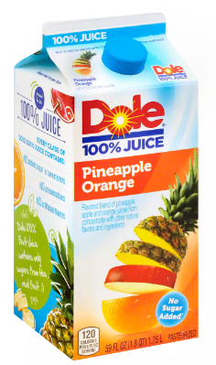
Dole 100% Pineapple Orange Juice
59 oz
$3.45 each
Description:
The whole fruit taste you love from the name you trust
4. Mango Juice
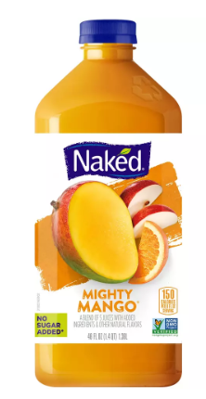
Naked Juice Mighty Mango
46 oz
$6.75
Description:
Give your morning the royal treatment with this amazingly exotic, incredibly yummy blend of mango, oranges, apples, and more. Simply put, mango rules.

